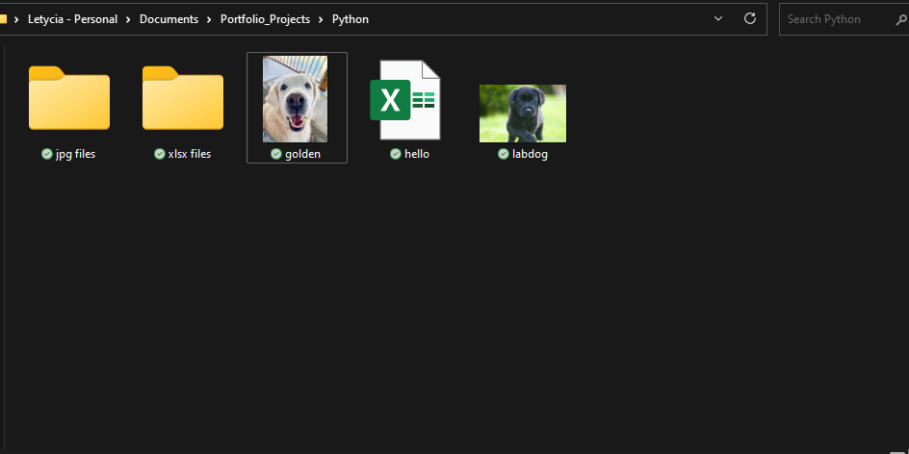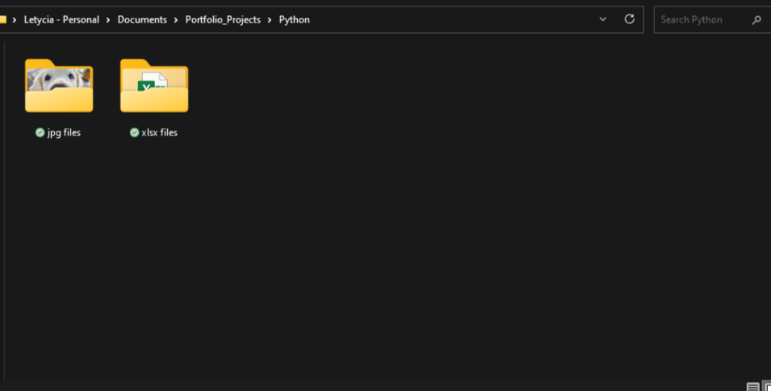

Here are pictures in my file, where I use Python to help sort them into their files as .jpeg and .xlsx files